LAYAN ALSHEHRI

201922351

CIS 201 project

*Index page:*

This is the main page, it contains small introduction to the CIS 201 course

It is connected to the following pages:

* About me
* Calculator
* Project
* Contact me

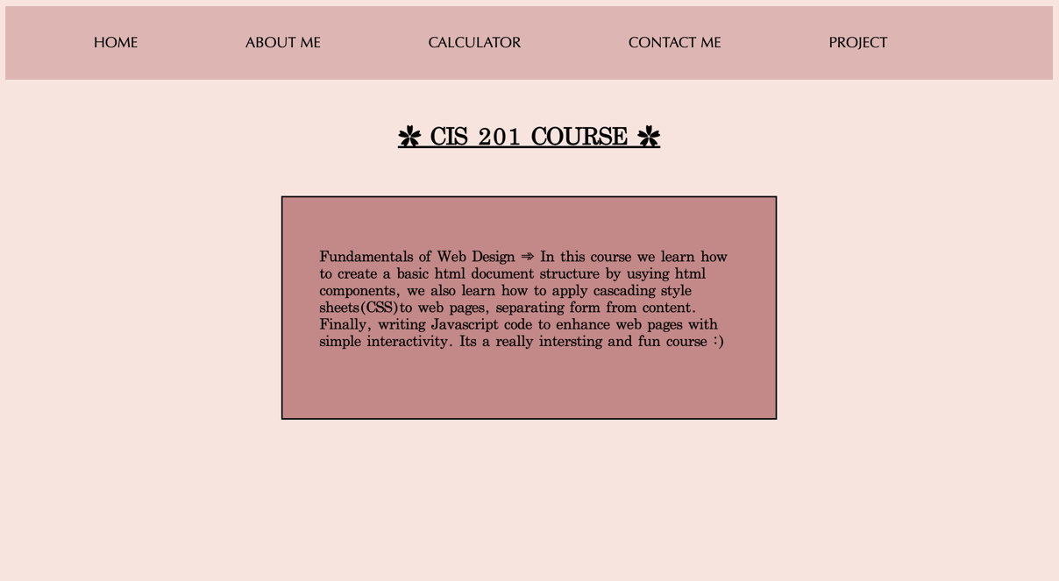

*About me page:*

Contains a small introduction about me.

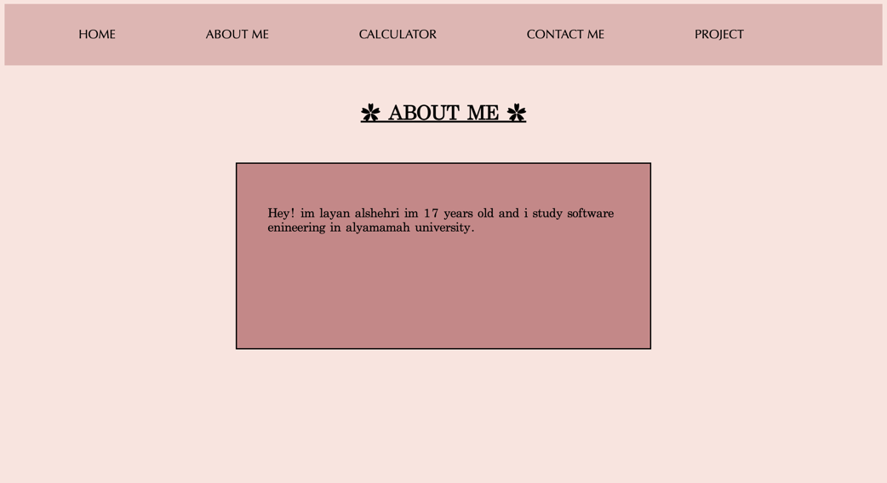

*Calculator:*

This page has a calculator

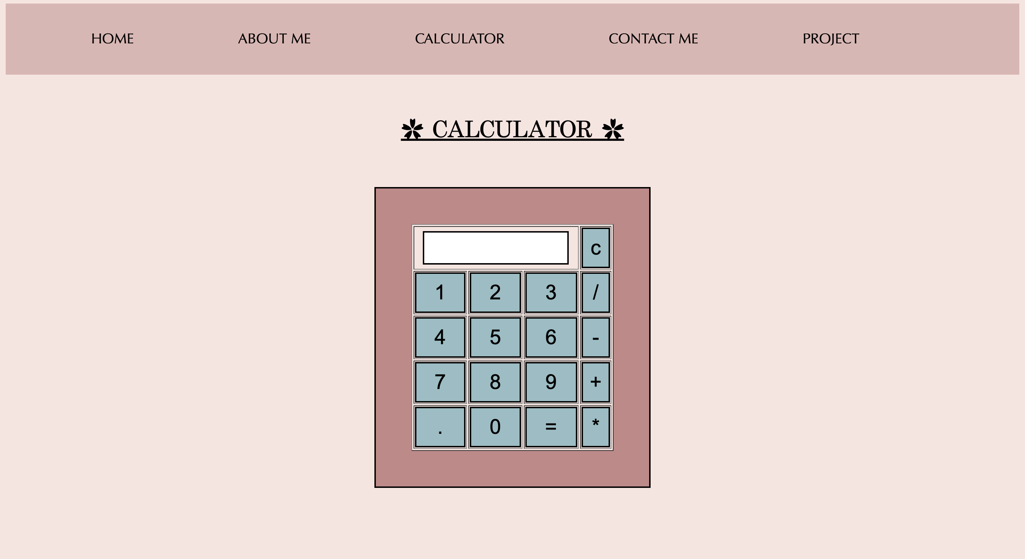

*Project:*

This page contains my restaurant menu project.

when you click on project it will directly take you to the home page.

The home page contains the restaurant logo.

Home page is connected to the following:

* Menu
* Contact us

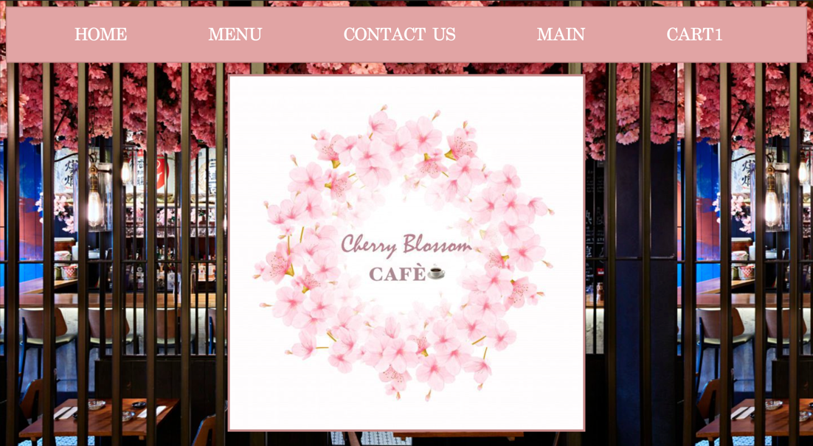

The menu page contains some desserts and drinks

There is a “add to cart” button, when you click on it, it will add the item to the cart.

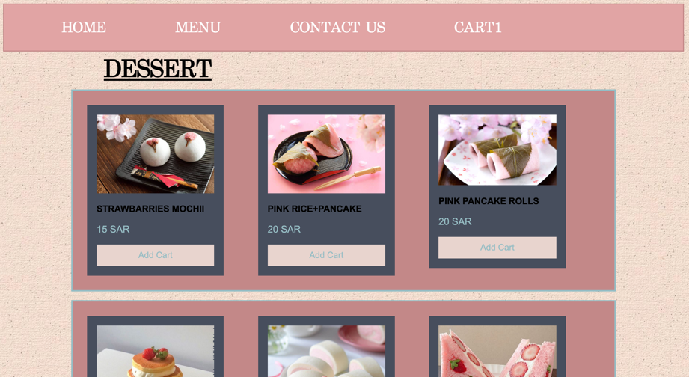

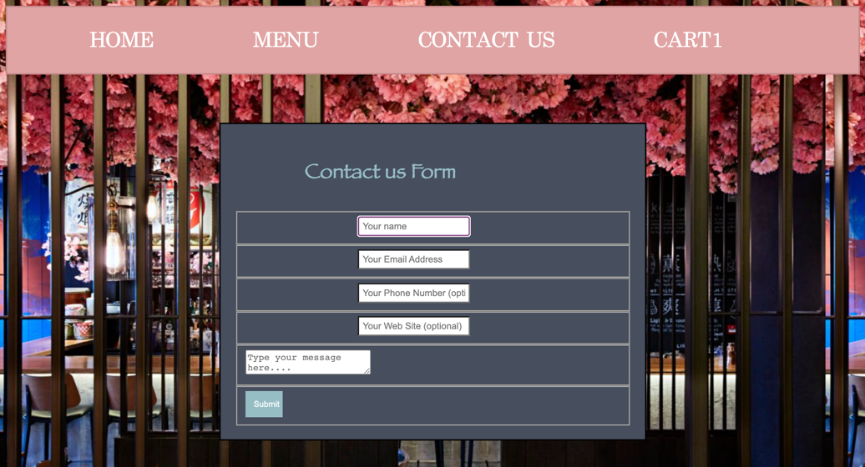Contact us page:

*External links:*

Stylesheet1.css {index, about me, contact me, calculator page}

Stylesheet2.css {main, menu, contact us}

Stylecal.css {styling the calculator itself}

Jsproject.js {the cart}

Caljs.js {calculator}